**Report 18.01.24**

**Study of strain in 3mm disc under torsion**

**Part A: Experiment:**

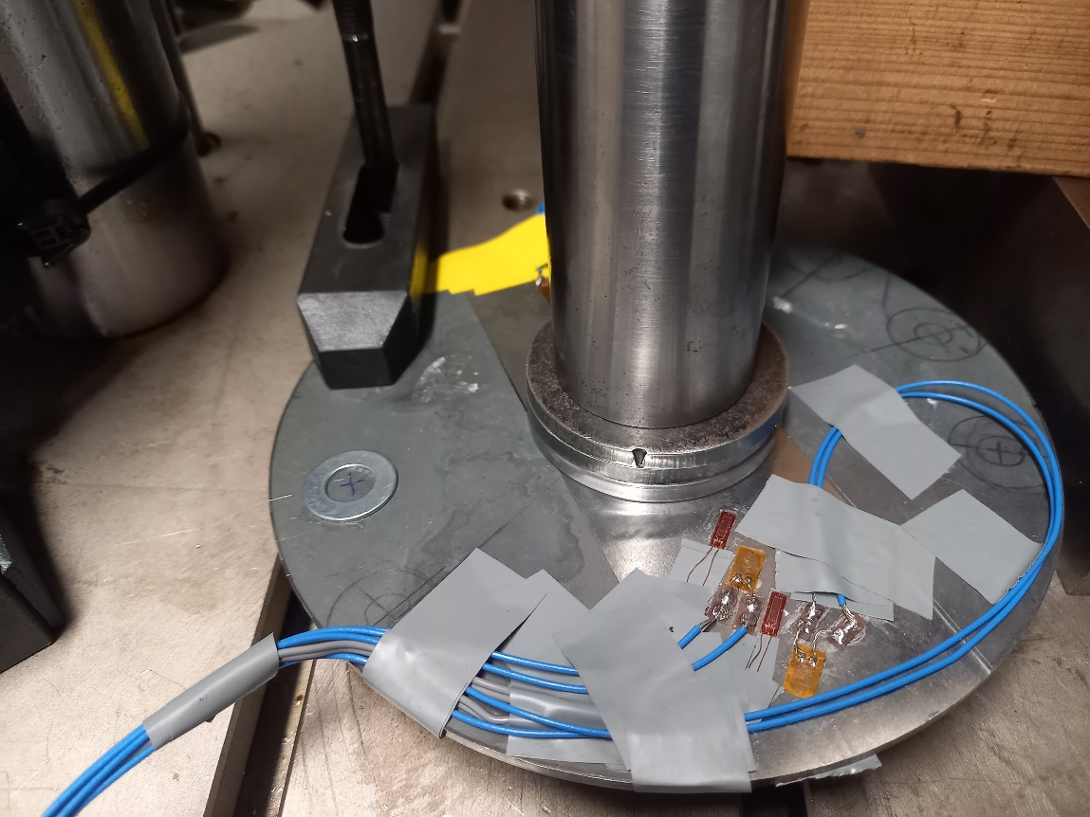Experimental Setup

Figure 1. Experimental set up

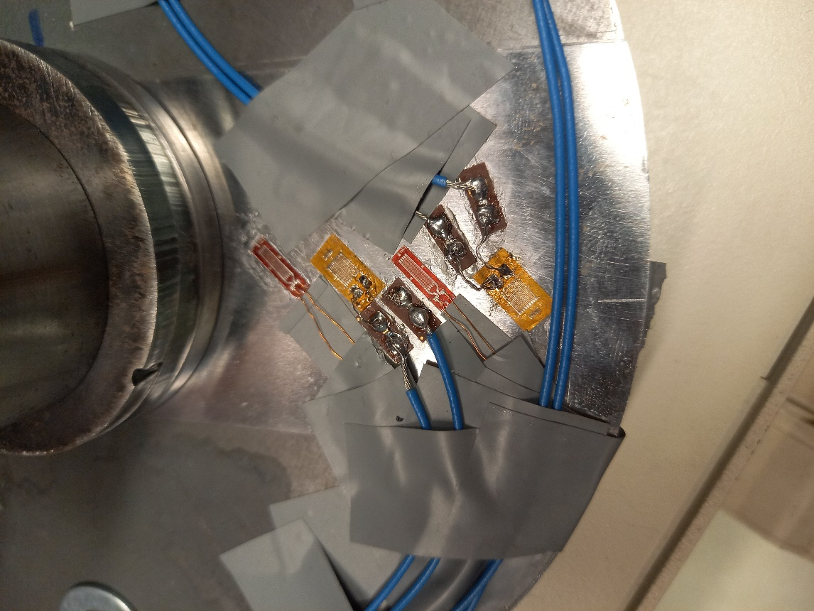

Sensor 3

Sensor 2

Sensor 4

Sensor 1

Figure 2. Strain gauge locations

|  |  |  |  |  |
| --- | --- | --- | --- | --- |
| Sensor 4 | **Sensor 1** | **Sensor 2** | **Sensor 3** | **Sensor 4** |
| **Type of sensor** | “Type A” | “Type B” | “Type A” | “Type B” |
| **Grid dimensions (mm)** | 5 x 1.5 | 4x3 | 5 x 1.5 | 4x3 |
| **Centre coordinates** | (-1,-40,3) | (0,-51,3) | (1,-63,3) | (-1,-76,3) |
| **Angle to X-axis** | = 49 degrees | = 51 degrees | = 51 degrees | = 49 degrees |
| **Resistance** | 120 *Ω* | 120 *Ω* | 120 *Ω* | 120 *Ω* |
| **Gauge factor** | 2.1 | 2.085 | 2.1 | 2.085 |
| **Channel in NI box** | CH 1 | CH2 | CH3 | CH4 |
| **Name on Labview** | ai1/ “strain_0” | ai2/ “strain_1” | ai3/ “strain_2” | ai4/ “strain_3” |

Table 1**.** Strain gauge info

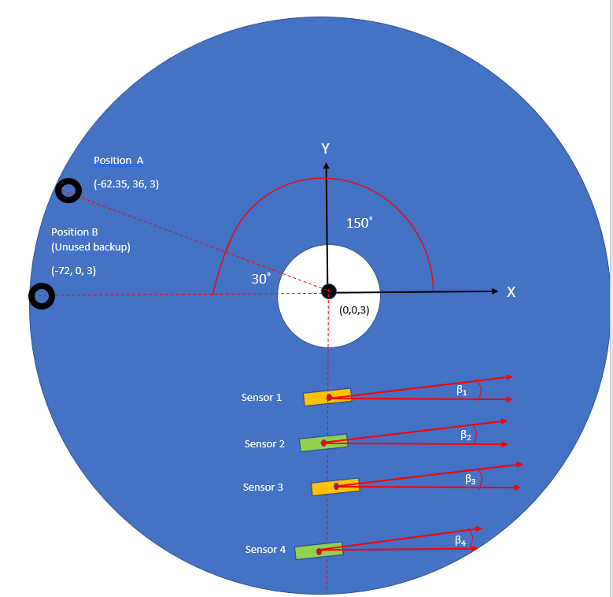

Figure 3. Diagram of experimental setup

Note: Black circles = washer positions. Washer centre locations are given in the coordinates below. Washers on bottom surface taken to have same coordinates as ones on top surface.

(0,0,0) is the centre of the bottom of the disc. (0,0,3) is located at centre of its top surface.

150˚

Experimental Method:

1. Paper template printed out and used as a guide during the strain gauge application process. The sensor coordinates were measured again after application, to see if they were applied as intended.
2. Note that the strain gauge application process was imperfect- sensors 1 and 2 did not adhere to the disc at the first attempt and had to be re-applied. Additionally, a small air bubble was present beneath the grid of sensor 4. These factors may contribute to inaccuracy in experimental results.
3. Instron
4. Disk 3 mm
5. Torque was applied clockwise
6. Sensor data in table 1; Vex source – internal; Vex value 2.5 V
7. Torque range 10, 20, 30 Nm
8. Port 1 - Strain 0 (information in DAQ system) - Sensor 1

Port 2 - Strain 1 - Sensor 2

Port 3 – Strain 2 - Sensor 3

Port 4- Strain 3- Sensor 4

1. Data file (column 1 - Sensor 1; column 2 - Sensor 2; column 3 - Sensor 3; column 4- Sensor 4)
2. LabView 2009
3. ¼ quarter bridge I for each sensor
4. Disc was clamped at one point- Position A in Figure 3

Experimental Results:

Figure 4. Experimental results for sensor 1 under applied torque

Figure 5. Experimental results for sensor 2 under applied torque

Figure 6. Experimental results for sensor 3 under applied torque

Figure 7. Experimental results for sensor 4 under applied torque

Figure 8. Experimental results for all sensors under different levels of applied torque

**Part B- Simulations:**

Simulation Parameters:

1. Higher order tetrahedral mesh used, of size 1mm.
2. 10, 20, 30 Nm torque applied to area of 5mm washers.
3. Fixed geometry applied to position A, modelled as same shape as M10 washer.
4. Edge sizing with (number of divisions = 1) applied to edges of strain gauges.
5. Contact choices- “Symmetrical” contact between surface body and disc, “pure penalty” formulation, disc=target and gauge=contact.
6. 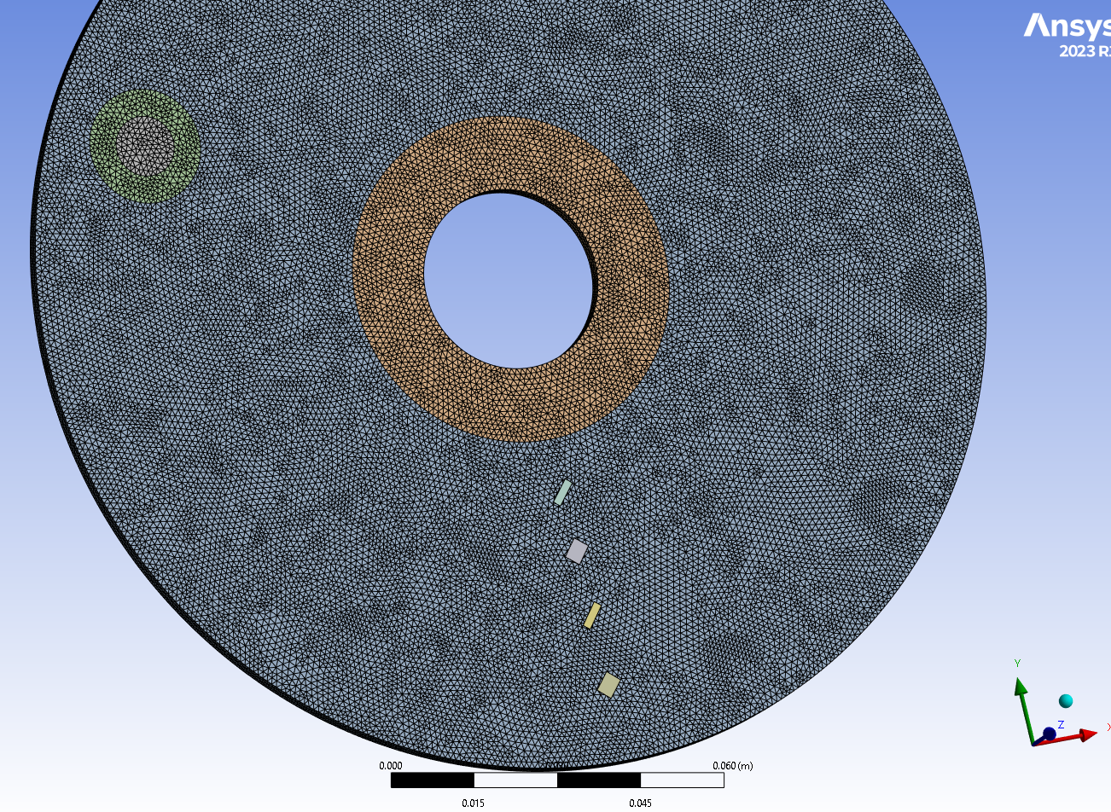Note- parameters may change- if a better method is found, the simulations will be revised.

Figure 9. Screenshot of finite element mesh

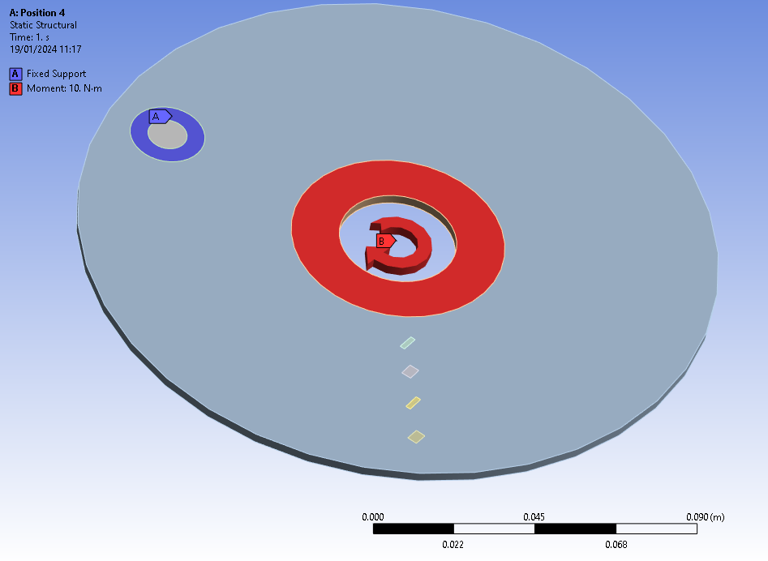

Figure 10. Screenshot of applied boundary conditions

Figure 10. Predicted strain sensor readings at different levels of torque

**Part C- Comparison of Results:**

Figure 11. Comparison of predicted and actual strain given by sensor 1 under applied torque

|  |  |  |  |
| --- | --- | --- | --- |
|  | **Sensor 1** | | |
| **Torque (Nm)** | **Experimental** | **ANSYS** | **Difference** |
| **10** | 1.63E-06 | -2.49E-06 | 253% |
| **20** | -2.94E-06 | -4.99E-06 | -69% |
| **30** | -6.97E-06 | -7.48E-06 | -7% |

Table 2. Comparison of predicted and actual strain values for sensor 1

Figure 13. Comparison of predicted and actual strain given by sensor 2 under applied torque

|  |  |  |
| --- | --- | --- |
| **Sensor 2** | | |
| **Experimental** | **ANSYS** | **Difference** |
| 7.26E-07 | -1.50E-06 | 305% |
| -5.32E-06 | -2.98E-06 | 44% |
| -9.08E-06 | -4.47E-06 | 51% |

Table 3. Comparison of predicted and actual strain values for sensor 2

Figure 14. Comparison of predicted and actual strain given by sensor 3 under applied torque

|  |  |  |
| --- | --- | --- |
| **Sensor 3** | | |
| **Experimental** | **ANSYS** | **Difference** |
| -8.0E-08 | -8.65E-07 | -988% |
| -4.33E-06 | -1.73E-06 | 60% |
| -7.49E-06 | -2.60E-06 | 65% |

Table 4. Comparison of predicted and actual strain values for sensor 3

Figure 15. Comparison of predicted and actual strain given by sensor 4 under applied torque

|  |  |  |
| --- | --- | --- |
| **Sensor 4** | | |
| **Experimental** | **ANSYS** | **Difference** |
| -6.06E-07 | -4.29E-07 | 29% |
| -5.52E-06 | -8.57E-07 | 84% |
| -7.49E-06 | -1.29E-06 | 83% |

Table 5. Comparison of predicted and actual strain values for sensor 4

Figure 16. Effect of sensor positioning along Y axis (experimental results). Note that the distance along the Y axis is the sensor’s radial distance from the centre of the disc.

Figure 17. Predicted effect of sensor positioning along Y axis (ANSYS). Note that the distance along the Y axis is the sensor’s radial distance from the centre of the disc.

**Part D- Observations**

Quantitative Observations:

1. As the applied torque increases the useful strain signal increases as follows:

|  |  |  |  |  |
| --- | --- | --- | --- | --- |
|  | 10-20 Nm | | 20-30 Nm | |
|  | Experimental | ANSYS | Experimental | ANSYS |
| Sensor 1 increase | -4.57E-06 | -2.49E-06 | -4.02E-06 | -2.49E-06 |
| Sensor 2 increase | -6.05E-06 | -1.49E-06 | -3.76E-06 | -1.49E-06 |
| Sensor 3 increase | -4.25E-06 | -8.65E-07 | -3.16E-06 | -8.65E-07 |
| Sensor 4 increase | -4.92E-06 | -4.29E-07 | -1.96E-06 | -4.29E-07 |

Table 6. increase in useful strain signal

1. Sensitivity to torque:

|  |  |  |  |  |
| --- | --- | --- | --- | --- |
|  | 10-20 Nm | | 20-30 Nm | |
|  | Experimental | ANSYS | Experimental | ANSYS |
| Sensor 1 | -4.57E-07 | -2.49E-07 | -4.02E-07 | -2.49E-07 |
| Sensor 2 | -6.05E-07 | -1.49E-07 | -3.76E-07 | -1.49E-07 |
| Sensor 3 | -4.25E-07 | -8.65E-08 | -3.16E-07 | -8.65E-08 |
| Sensor 4 | -4.92E-07 | -4.29E-08 | -1.96E-07 | -4.29E-08 |

Table 7. Sensitivity to torque

Qualitative observations:

|  |  |  |
| --- | --- | --- |
|  | **Expected Behaviour (ANSYS Predictions)** | **Experimental Finding- true or false** |
| 1. | Tensile strain exhibited at all 4 sensor locations for all 3 torque values | True for the most part. Incorrect only for sensor 1 at 10 Nm. |
| 2. | Linear increase in tensile strain with applied torque | True in general- not completely linear but would need to record the strain at more torque values to be certain |
| 3. | Barely noticeable strain increase for sensor 1 at 10 Nm, and no noticeable increase for sensors 2-4 at 10 Nm | True |
| 4. | Noticeable strain increases for all sensors at 20 Nm and 30 Nm | True |
| 5. | Highest sensitivity will be shown by sensors closest to centre of disc i.e. order of sensitivity goes from sensor 1>2>3>4 | **False-** order of sensitivity went from sensor 4>2>3>1 |

Table 8. Comparison of predicted and actual qualitative outcomes

**Part E- Conclusions:**

1. In general, the qualitative predictions from the ANSYS Finite Element model are proved correct by the experimental data.
2. However, prediction 5 was incorrect- the strain did not increase linearly with distance from the centre of the disc. In other words, the sensitivity of the strain gauges was not as predicted. This may be due to poor contact between the disc and sensors (i.e. faults in the strain gauge application process as outlined in the “experimental method” section).
3. The loading and unloading stages are not easily distinguishable in the graphs.

This is because strain was not fully restored to its resting level after unloading had occurred for the 20 Nm and 30 Nm tests. A 5 second unloading period and 10 second idle period were recorded after the end of the process, but it was not sufficient in these tests. The strain induced during the 20 Nm loading cycle remained in the disc until the start of the 30 Nm loading cycle. This can be seen in Figures 4-7, where a) the orange line doesn’t return to its original idle level after unloading, b) the grey line starts off at a different strain level to the others, and c) the grey line doesn’t return to its idle level after unloading.

1. In general, the FE model under-predicted the recorded strain magnitude and the strain gauges’ sensitivity to torque increases. This may indicate over-constraint in the ANSYS model.
2. Over-prediction of strain only occurred in the case of sensor 1- this is likely due to poor contact between sensor 1 and the disc. It also over-predicted strain for sensors 2 and 3 at 10 Nm- no obvious reason for this comes to mind.
3. The sensor coordinates on the disc were measured a number of times, with the measurements typically differing by 1-1.5 mm. An investigation into the effect of sensor location inaccuracy using ANSYS was carried out for previous experimental conditions. It revealed that sensor positioning inaccuracy of 1mm can result in 15-20% variations in recorded strain and inaccuracy of 5% can lead to 4-5% variations in strain. It may also be a significant factor in this experiment.

A better method for installing strain gauges on the disc is required to ensure a) the sensors are accurately placed in the correct location and b) the adhesion of the strain gauge to the disc is good, allowing for optimal strain transfer to the sensor.

1. Quantitative analysis is required to determine how many decimal places we can give for the experimental results. At present, only strain increases greater than 1E-06 m/m are being detected, so it will probably be something around that value. Any values below this will be influenced too much by noise- stating experimental results to the order of 1E-07 or 1E-08 is effectively overstating our accuracy.

**Part F- Calculations:**

|  |  |  |  |
| --- | --- | --- | --- |
|  | **Sensor 1** | | |
| **The force applied** | **10 Nm** | **20 Nm** | **30 Nm** |
| Idle level | 8.62E-06 | 8.62E-06 | 1.84E-06 |
| Work level | 1.02E-05 | 5.68E-06 | -5.13E-06 |
| Difference, numerical value | 1.63E-06 | -2.94E-06 | -6.97E-06 |
|  | **Sensor 2** | | |
| **The force applied** | **10 Nm** | **20 Nm** | **30 Nm** |
| Idle level | 4.18E-06 | 4.83E-06 | -2.03E-06 |
| Work level | 4.91E-06 | -4.93E-07 | -1.11E-05 |
| Difference, numerical value | 7.26E-07 | -5.32E-06 | -9.08E-06 |
|  | **Sensor 3** | | |
| **The force applied** | **10 Nm** | **20 Nm** | **30 Nm** |
| Idle level | 1.46E-06 | 1.60E-06 | -3.76E-06 |
| Work level | 1.38E-06 | -2.73E-06 | -1.12E-05 |
| Difference, numerical value | -7.95E-08 | -4.33E-06 | -7.49E-06 |
|  | **Sensor 4** | | |
| **The force applied** | **10 Nm** | **20 Nm** | **30 Nm** |
| Idle level | -1.24E-05 | -1.50E-05 | -2.20E-05 |
| Work level | -1.31E-05 | -2.05E-05 | -2.94E-05 |
| Difference, numerical value | -6.06E-07 | -5.52E-06 | -7.49E-06 |

Table 9.- Experimental strain calculations

|  |  |  |
| --- | --- | --- |
| **Applied Torque** | **10-20 Nm** | **20-30 Nm** |
|  | **Sensor 1** | |
| Δ Strain | -4.57E-06 | -4.02E-06 |
| Δ Force, Nm | 10 | 10 |
| S | -4.57E-07 | -4.02E-07 |
|  | **Sensor 2** | |
| Δ Strain | -6.05E-06 | -3.76E-06 |
| Δ Force, Nm | 10 | 10 |
| S | -6.05E-07 | -3.76E-07 |
|  | **Sensor 3** | |
| Δ Strain | -4.25E-06 | -3.16E-06 |
| Δ Force, Nm | 10 | 10 |
| S | -4.25E-07 | -3.16E-07 |
|  | **Sensor 4** | |
| Δ Strain | -4.92E-06 | -1.96E-06 |
| Δ Force, Nm | 10 | 10 |
| S | -4.92E-07 | -1.96E-07 |

Table 10.- Experimental sensitivity calculations

|  |  |  |
| --- | --- | --- |
| **Applied Torque** | **10-20 Nm** | **20-30 Nm** |
|  | **Sensor 1** | |
| Δ Strain | -2.49E-06 | -2.49E-06 |
| Δ Force, Nm | 10 | 10 |
| S | -2.49E-07 | -2.49E-07 |
|  | **Sensor 2** | |
| Δ Strain | -1.49E-06 | -1.49E-06 |
| Δ Force, Nm | 10 | 10 |
| S | -1.49E-07 | -1.49E-07 |
|  | **Sensor 3** | |
| Δ Strain | -8.65E-07 | -8.65E-07 |
| Δ Force, Nm | 10 | 10 |
| S | -8.65E-08 | -8.65E-08 |
|  | **Sensor 4** | |
| Δ Strain | -4.29E-07 | -4.29E-07 |
| Δ Force, Nm | 10 | 10 |
| S | -4.29E-08 | -4.29E-08 |

Table 11.- ANSYS sensitivity calculations